MYSTRAN-Users-Manual,
How to create a complete Manual PDF

The MYSTRAN-Users-Manual Word files are separated into several sections since Adobe S/W does not seem able to cope with the manual as one complete entity. The sections are:
- MYSTRAN-Users-Manual-part 1-of-2.doc (title page up to detailed description of the BDF)
- MYSTRAN-Users-Manual-part 2 of 2.doc
- MYSTRAN-Users-Appendix-A.doc
- MYSTRAN-Users-Appendix-B.doc
- MYSTRAN-Users-Appendix-C.doc
- MYSTRAN-Users-Appendix-D.doc
- MYSTRAN-Users-Appendix-E.doc
- MYSTRAN-Users-Appendix-F.doc

NOTE:
- The doc files must have been created using heading styles in order for the final pdf to have a TOC
- The only TOC in the Word files is in part 1 of 2 and must be a manual TOC for the complete document. (DO NOT CREATE AN AUTOMATED TOC FROM WITHIN WORD)

After all of the above doc files are completed
(NOTE-files MUST have been created or recently edited in WORD 2003, NOT WORD 365!!):

  - Open Adobe Acrobat and click on File → Create PDF → From File
  - Navigate to folder where MYSTRAN-Users-Manual-part 1-of-2.doc resides and click on it
  - Acrobat converts the doc file to a pdf: MYSTRAN-Users-Manual-part 1-of-2.pdf
  - In the pdf file click on File → Properties and under the Navigation tab select “Bookmarks Panel and Page”
  - Save MYSTRAN-Users-Manual-part 1-of-2.pdf
  - Do 1-5 for MYSTRAN-Users-Manual-part 2-of-2.doc and all of the Appendices
  - To put the complete MYSTRAN-Users-Manual.pdf together:
    - Open MYSTRAN-Users-Manual-part 1-of-2.pdf in Adobe Acrobat 9 and save it as MYSTRAN-Users-Manual.pdf
    - In Acrobat 9 go to Document → Insert Pages and insert MYSTRAN-Users-Manual-part 2-of-2.pdf AFTER the last page of part 1 of 2
    - Do the same for all of the Appendix-?.pdf files always remembering to insert them AFTER the end of the last section inserted
    - Save the final pdf as MYSTRAN-Users-Manual.pdf

The Bookmnarks Panel will have extra headers (as shown in the picture below) for each of the sections added above (i.e. Users’ part 2 of 2, Appendix A, etc. These can be removed by the following process:
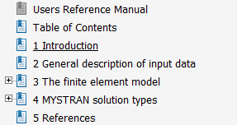
The bookmarks Panel looks like the following when MYSTRAN-Users-Manual-part 1-of-2.pdf is opened. Note, all sections in the Bookmarks Panel have been collapsed to the major headings (1, 2, 3, 4 and 5 in part-1-of-2):

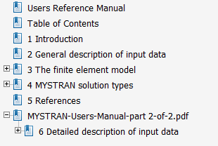
\When part-2-of-2.pdf is added (again, after closing the Bookmarks Panel to the major headings which is only #6 in this case) the picture to the right shows the Panel:

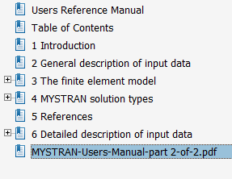
To get rid of the extraneous heading, “MYSTRAN-Users-Manual-part 2-of-2”, grab section 6 using the hand when the mouse hovers over it and drag it above “MYSTRAN-Users-Manual-part 2-of-2”, as seen here (be careful to position it just below the major section above, #5 (and not on top of 5 which could put section 6 inside of section 5):

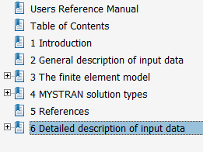
Now, the heading “MYSTRAN-Users-Manual-part 1-of-2” is isolated and it can be deleted by clicking on it and pressing “DEL” on the keyboard resulting in the image to the right

Do the above after each remaining section is added to the final pdf to get a clean Bookmarks Panel that looks like the following (with sections expanded to the 2nd level)
